AstraNotes Project Charter (Phase 1: Requirements & Scope)
1. Project Overview
AstraNotes is a high-performance, secure, and cross-platform note-taking application built in C++. Unlike standard apps, AstraNotes is designed for engineers who require markdown support, local-first encryption, and a modular architecture that can support "plugins" (Text, Voice, and Secure Notes).
AstraNotes is not just a "text editor." It is a High-Performance C++ Engineering Tool. Your goal this semester is to build a system that can handle thousands of notes with professional-grade security (encryption) and a modular "Plugin" architecture.

2. Core Technical Constraints (The "Non-Negotiables")
- Language: Strict C++ (C++17 or higher). In a graduate CS program, we use C++ because it requires Manual Precision. Unlike Python or Java, C++ will not hide your mistakes. You will learn to use AI to generate code, but you must use your own knowledge of RAII and Memory Management to ensure that code doesn't crash the system
- Memory Management: Students must use RAII and Smart Pointers (unique_ptr, shared_ptr). Manual new/delete is prohibited to prevent memory leaks.
- Architecture: Must follow the Model-View-Controller (MVC) pattern to ensure the business logic is decoupled from the UI.
- Auditability: Every module must be testable via Google Test (Gtest).
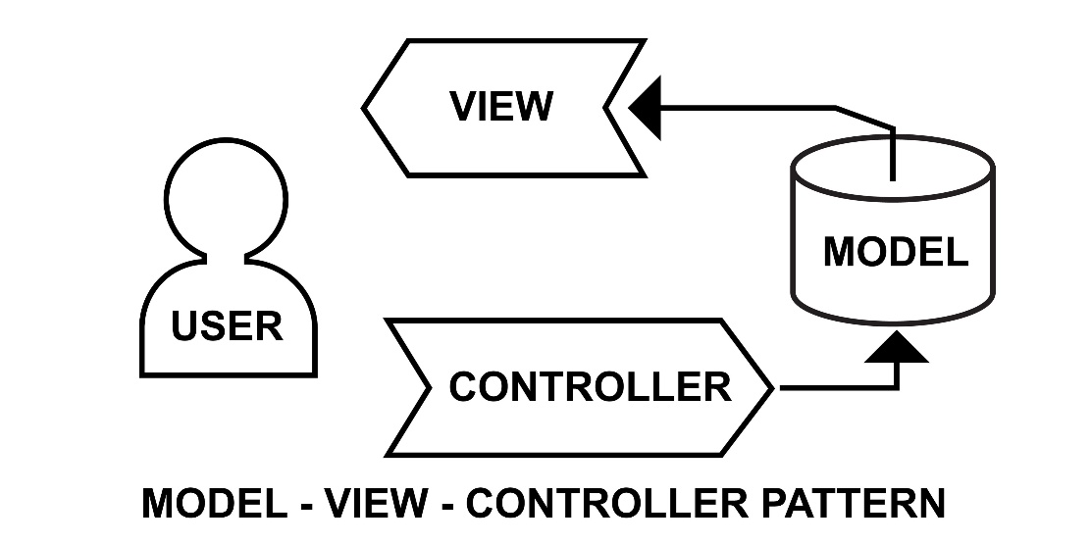
Shutterstock
3. High-Level Requirements (Intentional Ambiguity for Week 3)
Students will be given these "Vague Client Requests" and must use AI to deconstruct them into technical stubs:
- "The app should allow me to save different types of notes seamlessly."
- "I want to make sure my private notes are actually private."
- "The system should be fast, even if I have thousands of notes."
- "I need to see a history of my changes so I don't lose work."
4. The "Trust but Verify" First Task (Week 1 Lab)
Before writing code, students must:
- Use Chain-of-Thought Prompting to generate a high-level system architecture based on these requirements.
- Identify three potential AI Hallucinations or logic gaps in the suggested architecture (e.g., the AI suggesting a database library that doesn't exist or a memory-unsafe pattern).
- Draft the AstraNotes .h (Header) files manually to serve as the "Source of Truth" for the AI agents.
5. Your Roadmap for Week 1
Students often ask, "Should I start coding now?" The answer is NO. Here is your specific sequence:
- Step 1 (Today): Read the Project Charter. Understand the high-level requirements.
- Step 2 (Today's Lab): Attempt to map these requirements to a Waterfall Timeline. You will quickly see how a single change (like adding "Cloud Sync") makes a linear plan impossible.
- Step 3 (Wednesday): We will setup VS Code and GitHub Copilot. You will use AI to brainstorm the "Classes" needed for AstraNotes (e.g., NoteManager, EncryptionEngine, UserInterface).
6. Frequently Asked Questions (The "Confusion Killers")
Q: "I don't know C++ perfectly. Will I fail?"
- A: No. We provide "Syntax Primers." You will use AI to help with the boilerplate, but you are responsible for the Logic. If the AI suggests a memory-unsafe pointer, you must catch it.
Q: "What exactly am I building first?"
- A: For the first 4 weeks, you are building the Blueprint. You will create UML diagrams that act as the "Source of Truth." You won't write the core implementation logic until Week 6.
Q: "Can I just ask ChatGPT to write the whole app?"
- A: You can try, but you will fail the Technical Defense. In Mid-Term 2 and the Final, I will ask you to explain why a specific architectural choice was made. "The AI told me to" is a failing answer.

